“Київський фаховий коледж зв’язку”

# Циклова комісія Комп’ютерної інженерії

**ЗВІТ ПО ВИКОНАННЮ**

**WORK-CASE №3**

з дисципліни: «Операційні системи»

# Виконали студенти групи РПЗ-03:

Желевський Владислав, Гаврилей Володимир

# Київ 2022

**1.** Зробив Жлевський.В

**In the Virtual Box, VMWare Workstation (or another one of your choice), you need to do the following:**

* **Clone your virtual desktop OS (Work-case 2). How can this be done? can be done? Demonstrate all the steps;**
* **You may need to transfer (clone) the OS to another to another virtual environment. What steps do you need to take to export your virtual desktop OS?**

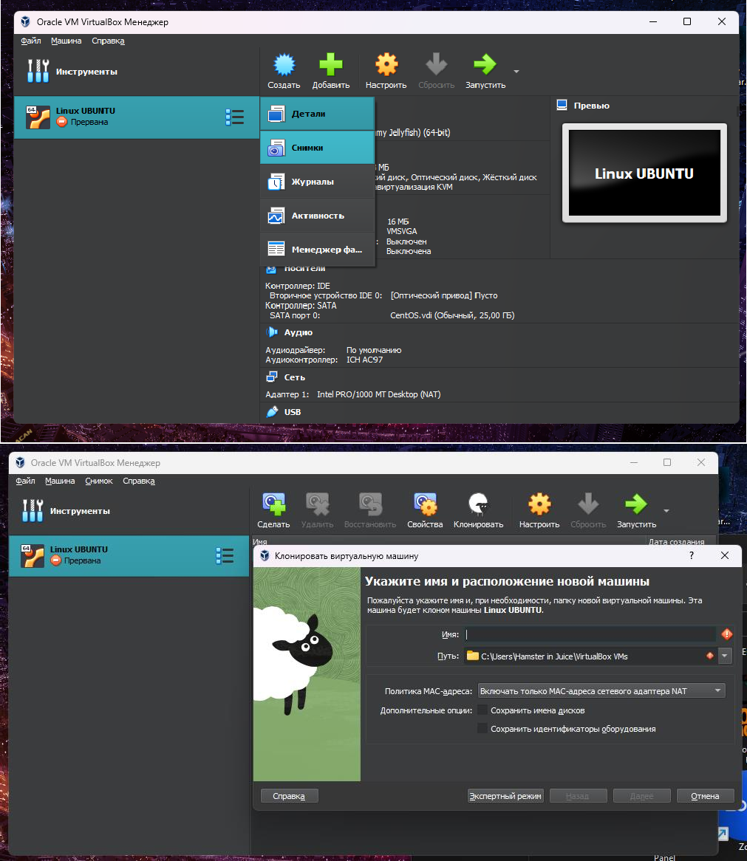

1. Open VirtualBox and select the virtual machine you want to clone.
2. Then select Snapshots in the toolbox and click the Clone button on the toolbar or go to Computer > Clone from the menu.
3. In the Clone Virtual Machine dialog box, type a name for the cloned virtual machine and select a location to save it.
4. Select whether you want to create a full clone or a linked clone. A full clone creates a completely separate copy of the original virtual machine, while a linked clone shares a virtual hard drive with the original virtual machine and takes up less space.
5. Click Clone to start the cloning process.

Steps to export your virtual working OS:

1. Select the virtual machine in the VirtualBox manager and go to File > Export Device, or you can also click the Export button on the toolbar.
2. In the Export Virtual Appliance window, select the virtual machine you want to export and choose a location to save the exported file.
3. Then select the format to which you want to export the virtual machine.
4. Click Next to configure the export settings.
5. Then click Export to start the export process.
6. Transfer the exported file to another virtual environment, such as another VirtualBox installation.
7. After all the monitoring, import the exported virtual machine into the new virtual environment by choosing File > Import Device or by clicking the Import button on the toolbar and selecting the exported file.

**2.** Зробив Гаврилей.В

**In the course of work, one working virtual machine can interact with another. To do this, you need to deploy a network between them. Describe what types of network connections are supported in a virtual machine environment and what is special about each type:**

* **Network Address Translation (NAT);**
* **Network bridge (Bridged);**
* **Host-only virtual adapter;**
* **Internal Network;**
  + Network Address Translation (NAT)

NAT is a mechanism in TCP/IP networks that allows changing the IP address in the header of a packet that passes through a traffic routing device. Also known as IP Masquerading, Network Masquerading, and Native Address Translation.

Types of NAT:

* NAT classification
* Symmetric NAT
* Cone NAT, Full Cone NAT
* Address-Restricted cone NAT, Restricted cone NAT
* Port-Restricted cone NAT NAT features include:
  1. Hides the internal structure of the network from prying eyes, unauthorized users cannot view any systems behind NAT, thereby increasing network security;
  2. Partially solves the issue of ending IPv4 addresses;
  3. Provides the possibility of using one IP address for the entire internal network when connecting to the Internet.
  + Network bridge (Bridged)

Bridged is the last Intel platform fully supported by Windows XP and the earliest Intel microarchitecture to support 64-bit Windows 10.

* + Host-only virtual adapter

The virtual host adapter (Host-only) works by default in the 192.168.56.0/24 network, the gateway/IP address of the adapter is 192.168.56.1, and the IP address is distributed to guests by DHCP. Connects a subnet and a host system without direct Internet access (the network is available to the host and guest).

When it is necessary that the guest be transparently visible on the local network (LAN), then it is necessary to select the Network Bridge and the physical network adapter, then if there is a DHCP server on the local network, the guest will automatically receive an IP address, if not then manually.

* + Internal Network

An internal network is a computer network that connects devices within a limited geographic area, such as a home, office, or building. The purpose of an internal network is to provide communication and data exchange between devices, allowing users to access resources such as printers, files, and applications.

The internal network can be configured using various technologies, including Ethernet, Wi-Fi and Bluetooth.

**3.** Зробив Жлевський.В

**Set up a network between your production OS and its clone (task 1):**

* **Demonstrate the basic commands for configuring network network settings and explain what they do.**

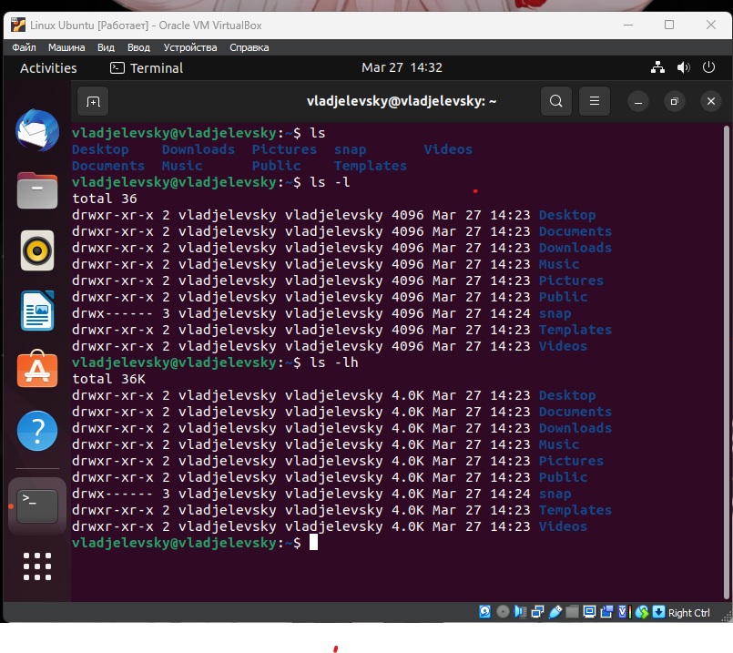

* Both operating systems must have access to the Internet. Open a browser and watch any video on YouTube

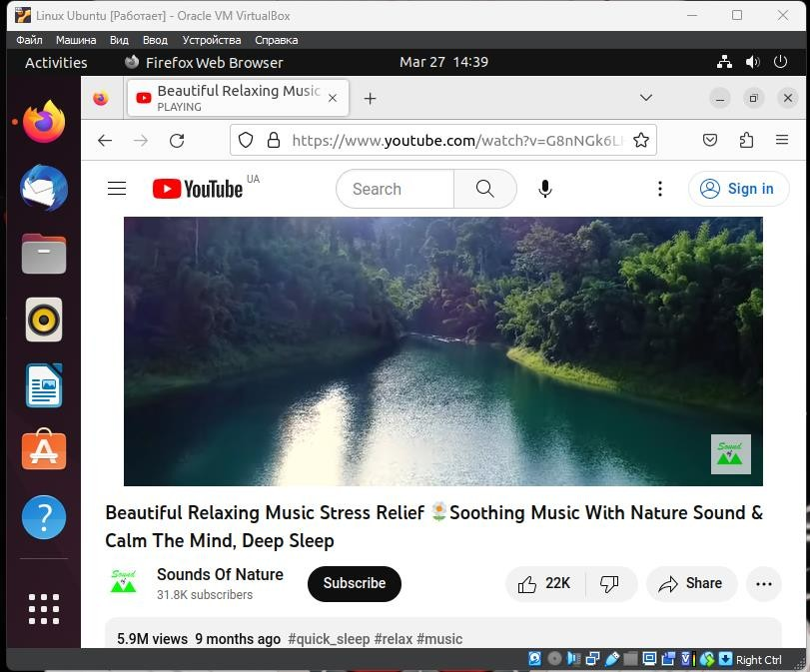

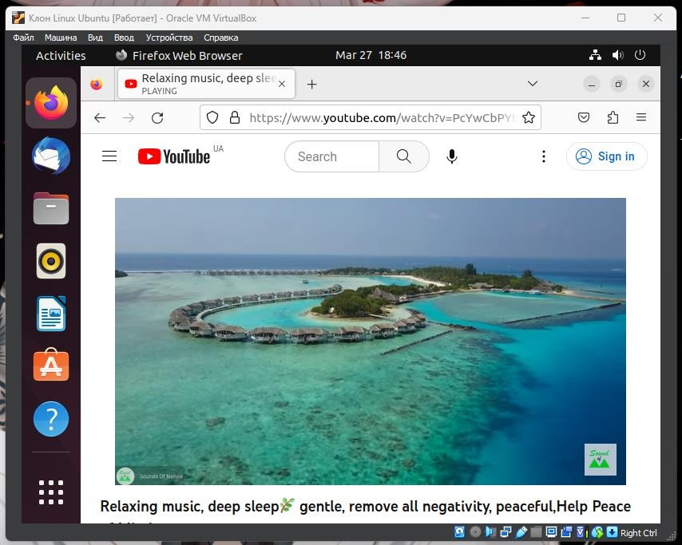

* Configure and demonstrate messaging between two operating systems over a local network. What commands do you need to enter in the terminal?

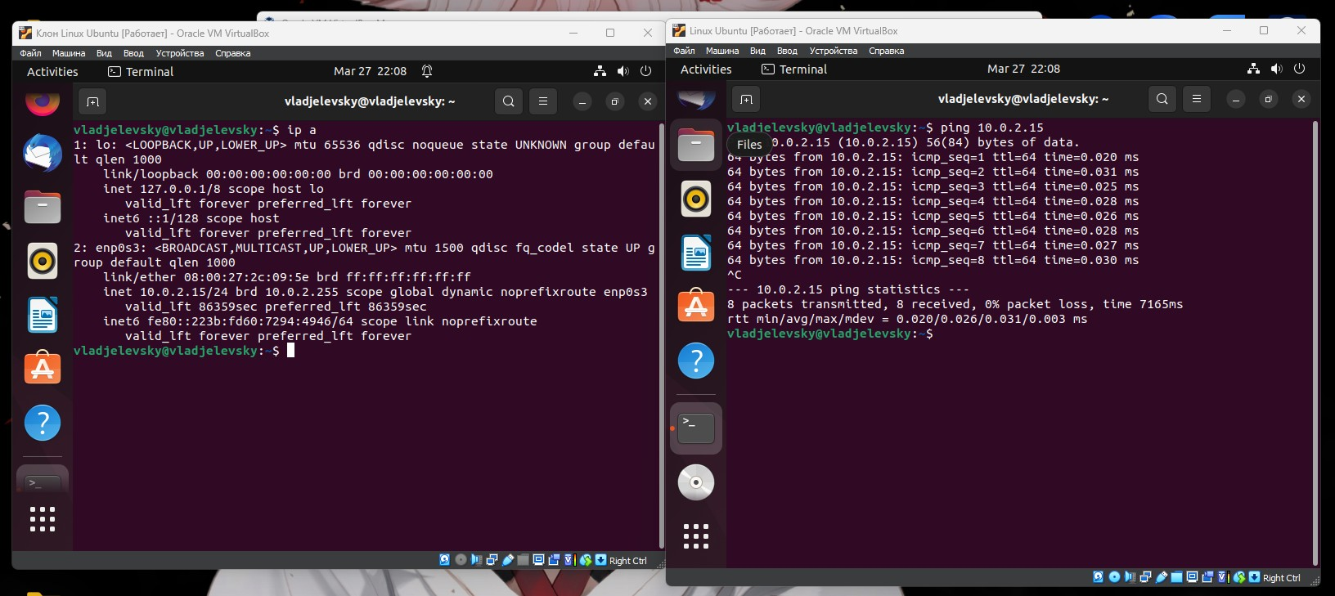

* Set up a shared network folder for both operating systems. Try copying files from this directory to the user's home directory (virtual operating system) and to the desktop (a clone of the virtual operating system).

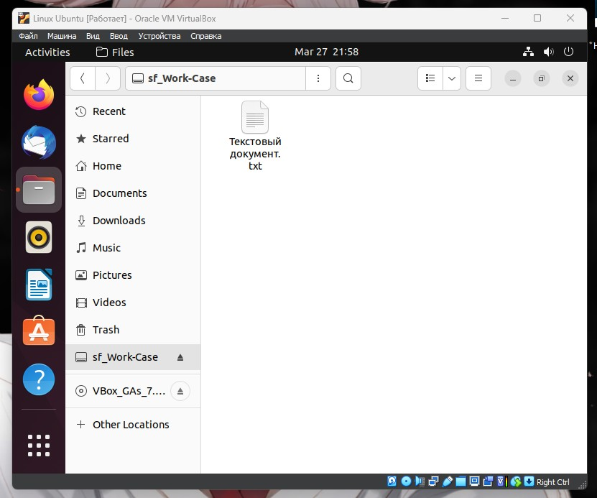

**4.** Зробив Гаврилей.В

**How can you organise the exchange of information between your main OS (e.g. Windows) and virtual OSes? Copy an arbitrary audio file from your main OS to the desktop of the virtual OS and its clone. How to. do the**

**opposite when you need a document from the virtual OS desktop to copy it to your main desktop?**

* To organize the exchange of information between your main OS (e.g. Windows) and virtual OSes, you can use a feature called "shared folders".
  1. Install the guest additions or tools: To use shared folders, you need to install the guest additions or tools provided by the virtualization software.
  2. Set up the shared folder: Once the guest additions or tools are installed, you can set up the shared folder.
  3. Access the shared folder: Once the shared folder is set up, you can access it from within the virtual OS.
* To copy a file from the desktop of the virtual OS to your main desktop, you need to:

1. Locate the file on the virtual OS desktop: Open the virtual OS and navigate to the file you want to copy.
2. Copy the file: Right-click on the file and select "Copy"
3. Paste the file on your main desktop: Switch to your main OS and navigate to the desktop. Right-click on an empty area and select "Paste".